**TEMA 3**

**Cazuri de testare**

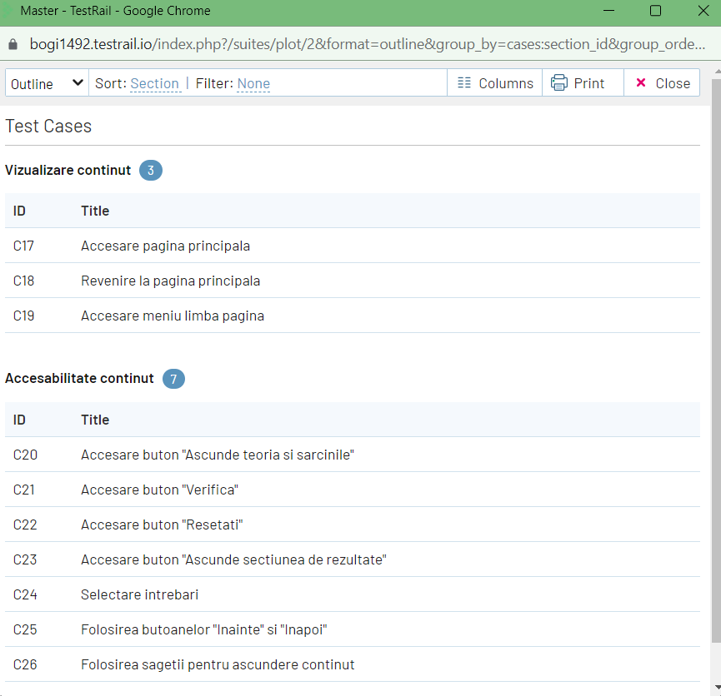

Pentru toate cele 10 cazuri de testare voi atasa print screen-uri in ordinea cazurilor prezentate mai sus:

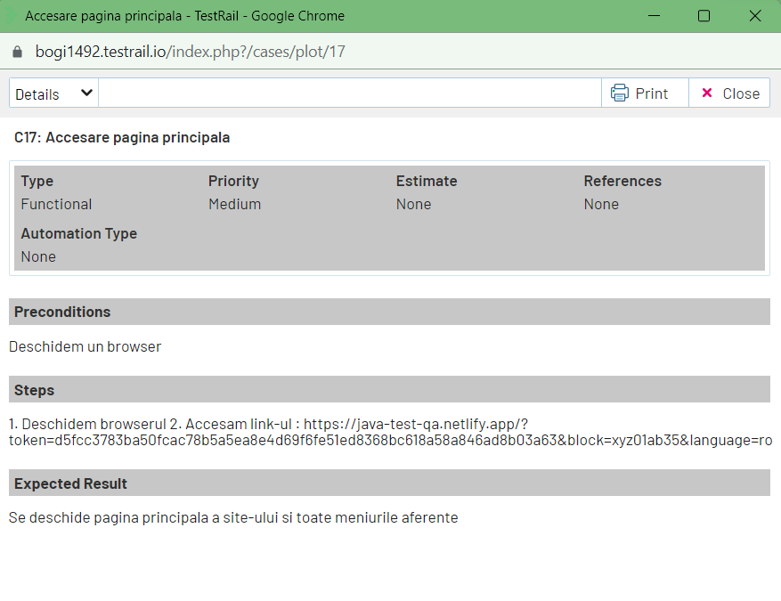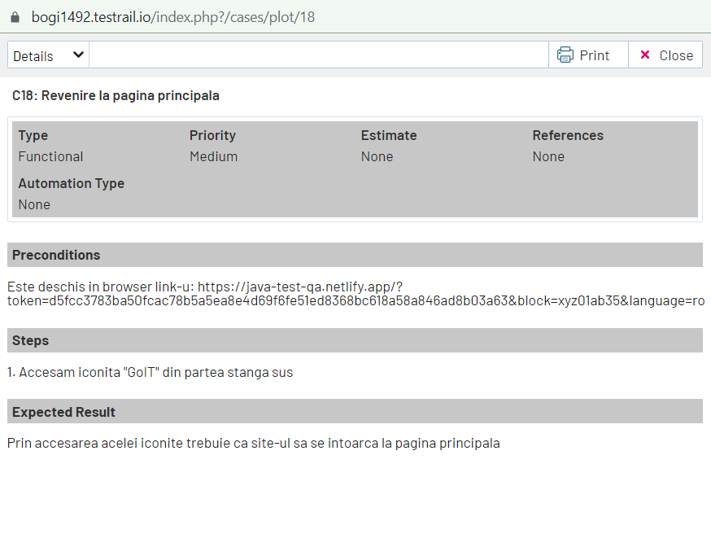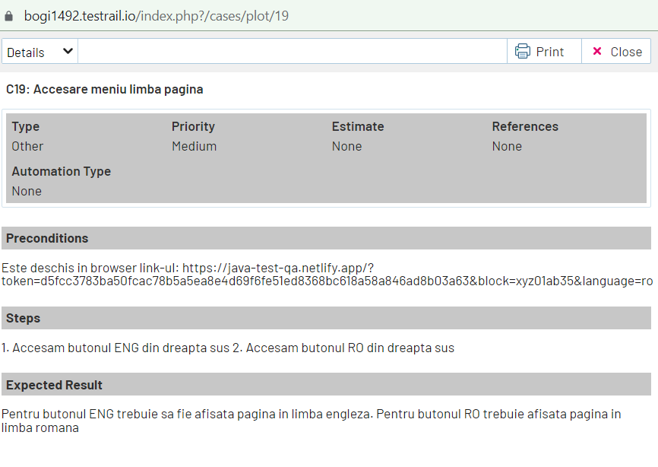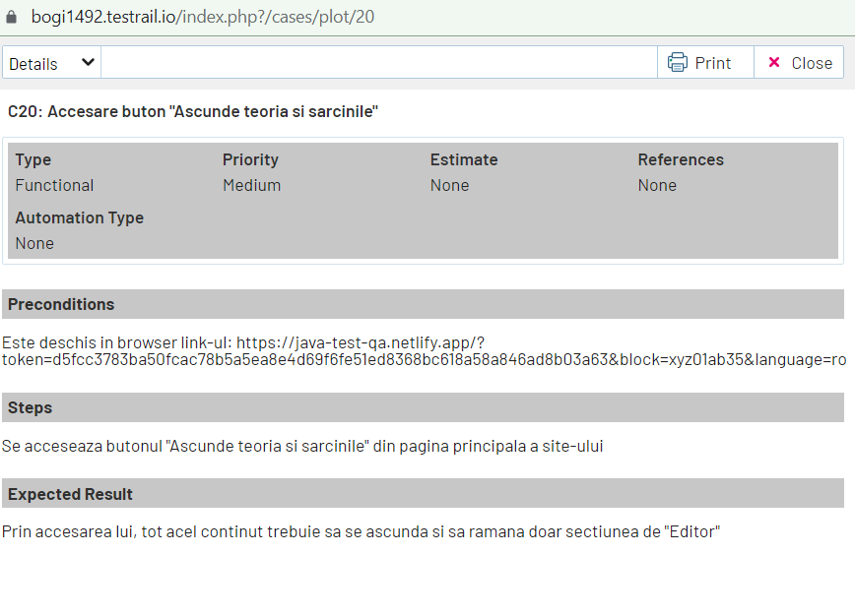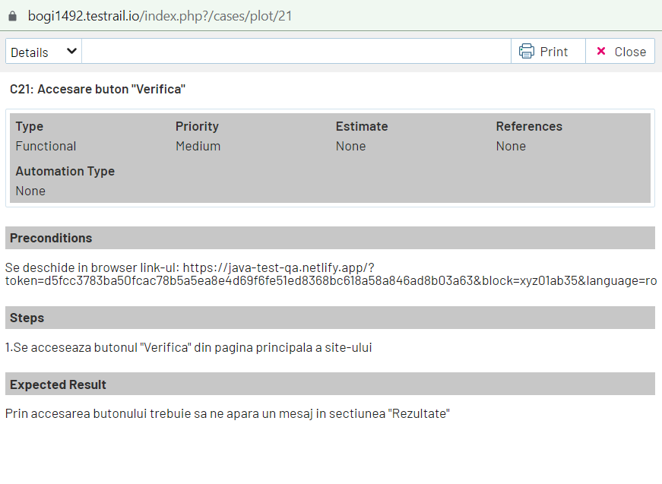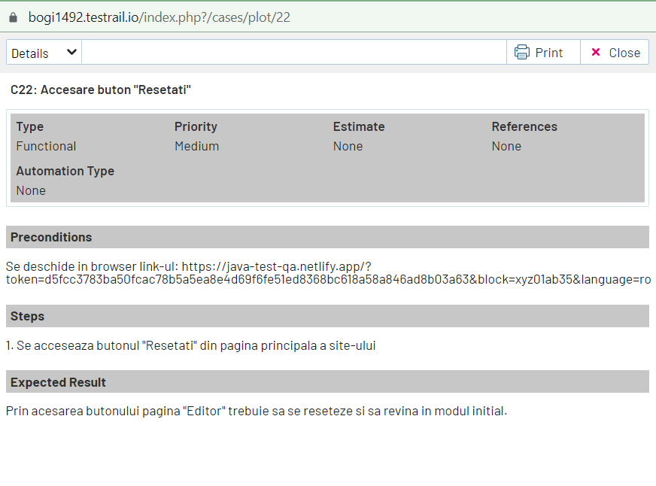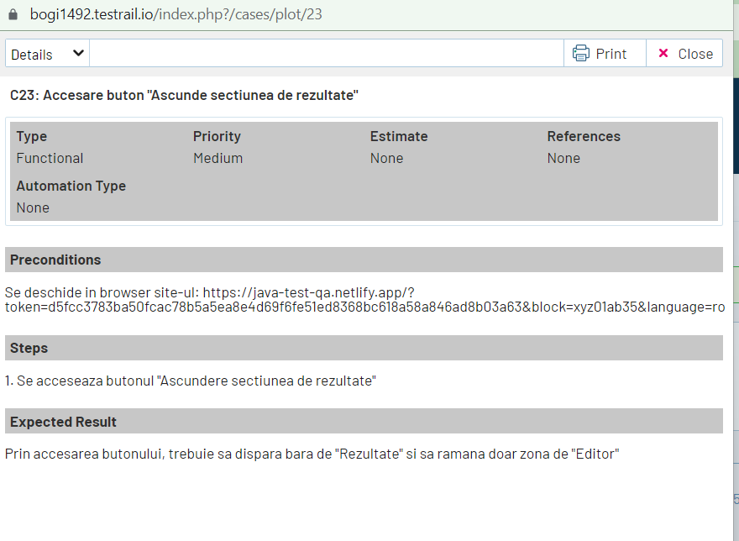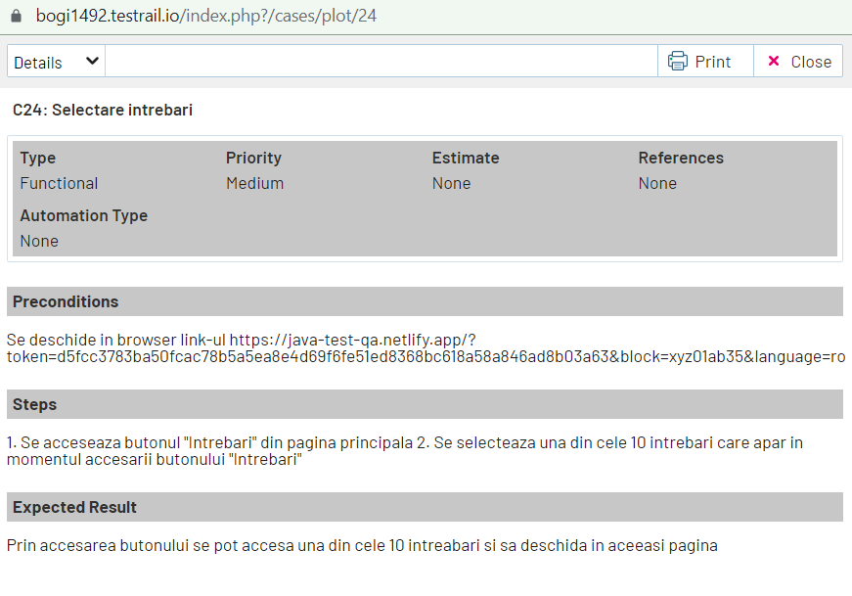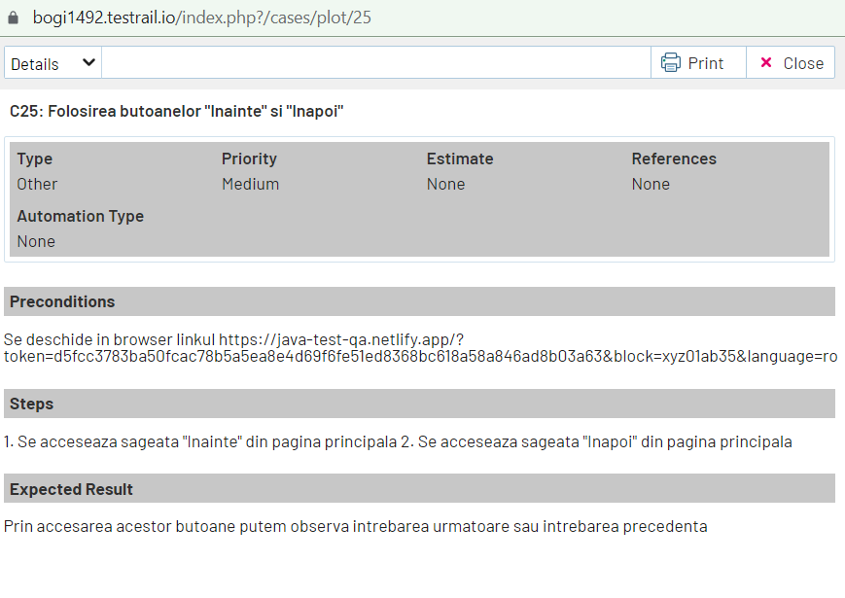

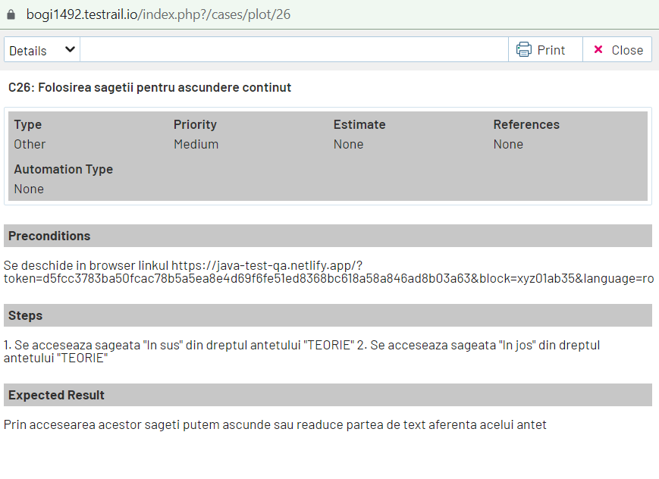

**BUG REPORTS**

1.

| ID | C18 |  |  |  |  |
| --- | --- | --- | --- | --- | --- |
| **Reporter:** | Dumitrache Bogdan | **Assignee:** | <Tester> | **Status:** | NEW |
| **Type:** | Functional | **Severity:** | Medium | **Priority:** | High |
| **Browser:** | Google Chrome 101.0 | **OS:** | Windows | **OS version** | 11 |
| **Summary:** | Eroare revenire la pagina principala | | | | |
| **Description:** |  | | | | |
|  | | | | |
| **Pre-conditions:** | | | | | |
| 1 | Am deschis browserul si am acesat pagina principala | | | | |
| 2 |  | | | | |
| **Steps to reproduce:** | | | | | |
| 1 | Deschideti pagina principala | | | | |
| 2 | Accesati iconita “GoIT” din partea din stanga sus a site-ului | | | | |
| 3 |  | | | | |
| 4 |  | | | | |
| **Actual result:** | | | | | |
| Site-ul nu a revenit la pagina principala ci am fost redirectionat catre site-ul: https://goiteens.com/ | | | | | |
|  | | | | | |
| **Expected result:** | | | | | |
| Revenirea la pagina principala | | | | | |
|  | | | | | |
| **Attachments:** | <captura de ecran> | | | | |
| **Additional info:** | | | | | |
|  | | | | | |
|  | | | | | |

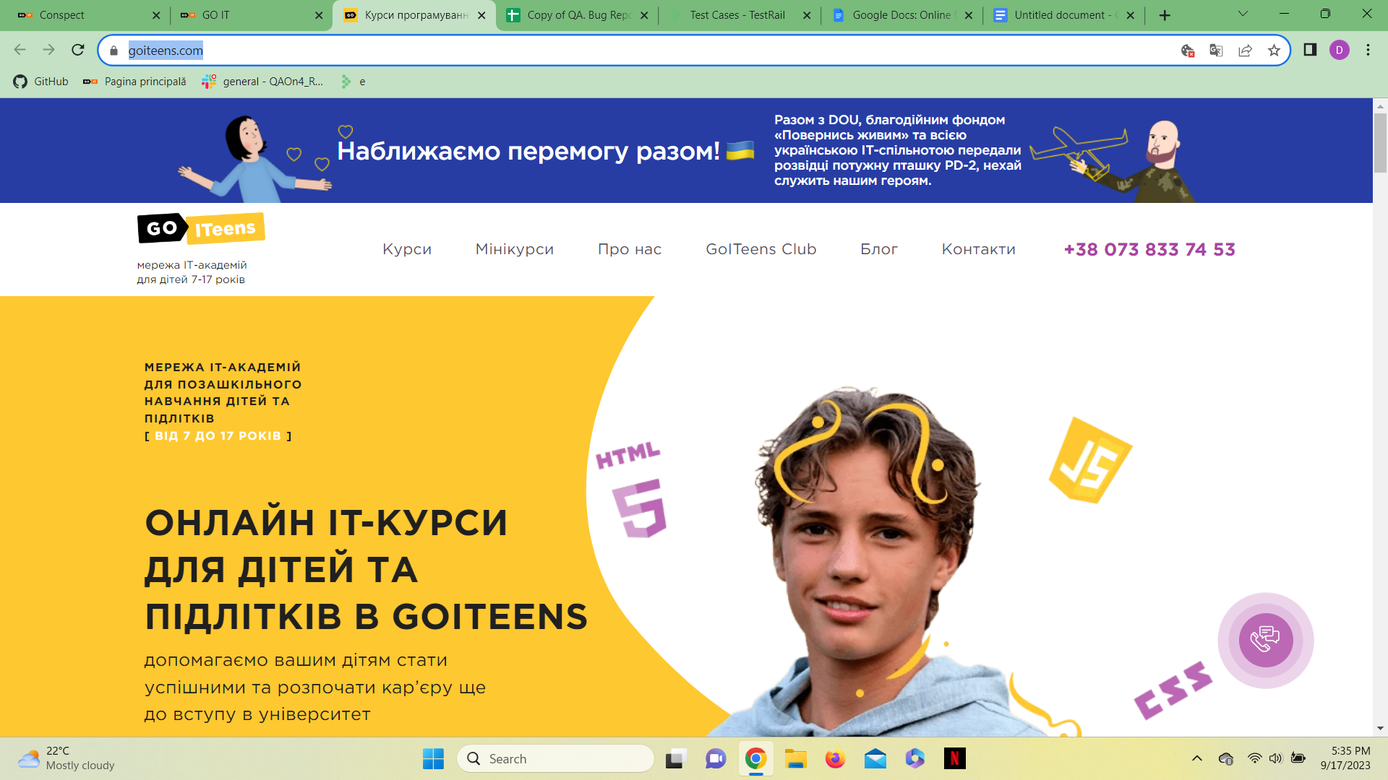

2.

| ID | C19 |  |  |  |  |
| --- | --- | --- | --- | --- | --- |
| **Reporter:** | Dumitrache Bogdan | **Assignee:** | <Tester> | **Status:** | NEW |
| **Type:** | Functional | **Severity:** | Minor | **Priority:** | High |
| **Browser:** | Google Chrome 101.0 | **OS:** | Windows | **OS version** | 11 |
| **Summary:** | Eroare accesare butoane schimbare limba | | | | |
| **Description:** |  | | | | |
|  | | | | |
| **Pre-conditions:** | | | | | |
| 1 | Este deschisa pagina principala a site-ului | | | | |
| 2 |  | | | | |
| **Steps to reproduce:** | | | | | |
| 1 | Accesati butonul “ENG” din partea dreapta sus a paginii principale | | | | |
| 2 |  | | | | |
| 3 |  | | | | |
| 4 |  | | | | |
| **Actual result:** | | | | | |
| Butonul nu functioneaza, nu poate fi apasat | | | | | |
|  | | | | | |
| **Expected result:** | | | | | |
| Prin accesarea butonului “ENG” pagina trebuia sa apara in limba engleza | | | | | |
|  | | | | | |
| **Attachments:** |  | | | | |
| **Additional info:** | | | | | |
|  | | | | | |
|  | | | | | |

3.

| ID | C19 |  |  |  |  |
| --- | --- | --- | --- | --- | --- |
| **Reporter:** | Dumitrache Bogdan | **Assignee:** | <Tester> | **Status:** | New |
| **Type:** | Functional | **Severity:** | Minor | **Priority:** | High |
| **Browser:** | Google Chrome 101.0 | **OS:** | Windows | **OS version** | 11 |
| **Summary:** | Eroare accesare butoane schimbare limba | | | | |
| **Description:** |  | | | | |
|  | | | | |
| **Pre-conditions:** | | | | | |
| 1 | Este deschis site-ul in pagina principala | | | | |
| 2 |  | | | | |
| **Steps to reproduce:** | | | | | |
| 1 | Accesati butonul “RO” din partea dreapta sus a paginii principale | | | | |
| 2 |  | | | | |
| 3 |  | | | | |
| 4 |  | | | | |
| **Actual result:** | | | | | |
| Butonul poate fi accesat insa nu produce nicio schimbare, pagina nu se reincarca in limba romana | | | | | |
|  | | | | | |
| **Expected result:** | | | | | |
| Prin accesarea butonului pagina trebuia asa se reincarce in limba romana | | | | | |
|  | | | | | |
| **Attachments:** |  | | | | |
| **Additional info:** | | | | | |
|  | | | | | |
|  | | | | | |

4.

| ID | C20 |  |  |  |  |
| --- | --- | --- | --- | --- | --- |
| **Reporter:** | Dumitrache Bogdan | **Assignee:** | <Tester> | **Status:** | New |
| **Type:** | Functional | **Severity:** | Medium | **Priority:** | High |
| **Browser:** | Google Chrome 101.0 | **OS:** | Windows | **OS version** | 11 |
| **Summary:** | Eroare incadrare continut dupa accesarea butonului | | | | |
| **Description:** |  | | | | |
|  | | | | |
| **Pre-conditions:** | | | | | |
| 1 | Accesati pagina principala a site-ului | | | | |
| 2 |  | | | | |
| **Steps to reproduce:** | | | | | |
| 1 | Accesati butonul “Ascunde teoria si sarcinile” | | | | |
| 2 |  | | | | |
| 3 |  | | | | |
| 4 |  | | | | |
| **Actual result:** | | | | | |
| Butonul functioneaza, continutul dispare, insa incadrarea sectiunii “Editor” este total gresita, pagina fiind de neutilizat | | | | | |
|  | | | | | |
| **Expected result:** | | | | | |
| Prin accesarea butonului dispare sectiunea “Ascunde teoria si sarcinile” iar sectiunea “Editor” este incadrata pe toata suprafata paginii principale facand utilizarea mult mai facila | | | | | |
|  | | | | | |
| **Attachments:** |  | | | | |
| **Additional info:** | | | | | |
|  | | | | | |
|  | | | | | |

5.

| ID | C21 |  |  |  |  |
| --- | --- | --- | --- | --- | --- |
| **Reporter:** | Dumitrache Bogdan | **Assignee:** | <Tester> | **Status:** | New |
| **Type:** | Functional | **Severity:** | High | **Priority:** | High |
| **Browser:** | Google Chrome 101.0 | **OS:** | Windows | **OS version** | 11 |
| **Summary:** | Nefunctionalitate butonului “Verifica” | | | | |
| **Description:** |  | | | | |
|  | | | | |
| **Pre-conditions:** | | | | | |
| 1 | Accesati pagina principala a site-ului | | | | |
| 2 |  | | | | |
| **Steps to reproduce:** | | | | | |
| 1 | Accesati butonul “Verifica” | | | | |
| 2 |  | | | | |
| 3 |  | | | | |
| 4 |  | | | | |
| **Actual result:** | | | | | |
| Butonul “Verifica” este nefunctional, nu se afiseaza niciun rezultat in urma accesari acestui buton | | | | | |
|  | | | | | |
| **Expected result:** | | | | | |
| Prin accesarea butonului, trebuia sa apara in sectiunea “Rezultate” rezultatul verificarii facute | | | | | |
|  | | | | | |
| **Attachments:** |  | | | | |
| **Additional info:** | | | | | |
|  | | | | | |
|  | | | | | |

6.

| ID | C21 |  |  |  |  |
| --- | --- | --- | --- | --- | --- |
| **Reporter:** | Dumitrache Bogdan | **Assignee:** | <Tester> | **Status:** | New |
| **Type:** | Functional | **Severity:** | High | **Priority:** | High |
| **Browser:** | Google Chrome 101.0 | **OS:** | Windows | **OS version** | 11 |
| **Summary:** | Eroare buton “Verifica” introducere text eronat | | | | |
| **Description:** |  | | | | |
|  | | | | |
| **Pre-conditions:** | | | | | |
| 1 | Accesati pagina principala a site-ului | | | | |
| 2 |  | | | | |
| **Steps to reproduce:** | | | | | |
| 1 | Introduceti text eronat in zona de editor | | | | |
| 2 | Accesati butonul “Verifica” | | | | |
| 3 |  | | | | |
| 4 |  | | | | |
| **Actual result:** | | | | | |
| Butonul este complet nefuntional, nu afiseaza niciun rezultat | | | | | |
|  | | | | | |
| **Expected result:** | | | | | |
| Prin accesarea butonului trebuia afisata o eroare pentru introducere text eronat | | | | | |
|  | | | | | |
| **Attachments:** |  | | | | |
| **Additional info:** | | | | | |
|  | | | | | |
|  | | | | | |

7.

| ID | C21 |  |  |  |  |
| --- | --- | --- | --- | --- | --- |
| **Reporter:** | Dumitrache Bogdan | **Assignee:** | <Tester> | **Status:** | New |
| **Type:** | Functional | **Severity:** | Medium | **Priority:** | Medium |
| **Browser:** | Google Chrome 101.0 | **OS:** | Windows | **OS version** | 11 |
| **Summary:** | Eroare buton “Verifica” neintroducere text | | | | |
| **Description:** |  | | | | |
|  | | | | |
| **Pre-conditions:** | | | | | |
| 1 | Accesati pagina principala a site-ului | | | | |
| 2 |  | | | | |
| **Steps to reproduce:** | | | | | |
| 1 | Lasati necompletata sectiunea “Editor” | | | | |
| 2 | Accesati butonul “Verifica” | | | | |
| 3 |  | | | | |
| 4 |  | | | | |
| **Actual result:** | | | | | |
| Buton complet nefuntional, nu afiseaza niciun rezultat | | | | | |
|  | | | | | |
| **Expected result:** | | | | | |
| Prin accesarea butonului trebuia sa fie afisat o eroare pentru neintroducere text | | | | | |
|  | | | | | |
| **Attachments:** |  | | | | |
| **Additional info:** | | | | | |
|  | | | | | |
|  | | | | | |

8.

| ID | C22 |  |  |  |  |
| --- | --- | --- | --- | --- | --- |
| **Reporter:** | Dumitrache Bogdan | **Assignee:** | <Tester> | **Status:** | New |
| **Type:** | Functional | **Severity:** | Medium | **Priority:** | Medium |
| **Browser:** | Google Chrome 101.0 | **OS:** | Windows | **OS version** | 11 |
| **Summary:** | Eroare buton “Resetati” pentru intrebarea 2 | | | | |
| **Description:** |  | | | | |
|  | | | | |
| **Pre-conditions:** | | | | | |
| 1 | Accesati pagina principala a site-ului | | | | |
| 2 |  | | | | |
| **Steps to reproduce:** | | | | | |
| 1 | Accesati intrebarea nr.2 | | | | |
| 2 | Editati text in sectiunea “Editor” | | | | |
| 3 | Accesati butonul “Resetati” | | | | |
| 4 |  | | | | |
| **Actual result:** | | | | | |
| Butonul nu functioneaza, nu se produce nicio schimbare | | | | | |
|  | | | | | |
| **Expected result:** | | | | | |
| Prin accesarea butonului, intrebarea trebuia sa revina la starea initiala | | | | | |
|  | | | | | |
| **Attachments:** |  | | | | |
| **Additional info:** | | | | | |
|  | | | | | |
|  | | | | | |

9.

| ID | C18 |  |  |  |  |
| --- | --- | --- | --- | --- | --- |
| **Reporter:** | Dumitrache Bogdan | **Assignee:** | <Tester> | **Status:** | New |
| **Type:** | Functional | **Severity:** | Minor | **Priority:** | Minor |
| **Browser:** | Google Chrome 101.0 | **OS:** | Windows | **OS version** | 11 |
| **Summary:** | Reimprospatare eronata a paginii | | | | |
| **Description:** |  | | | | |
|  | | | | |
| **Pre-conditions:** | | | | | |
| 1 | Accesati pagina principala a site-ului | | | | |
| 2 |  | | | | |
| **Steps to reproduce:** | | | | | |
| 1 | Accesati una din intrebari | | | | |
| 2 | Accesati butonul de “Reimprospatare” (Refresh) al browser-ului | | | | |
| 3 |  | | | | |
| 4 |  | | | | |
| **Actual result:** | | | | | |
| Pagina se reimprospateaza insa revine mereu la intrebarea nr 10 | | | | | |
|  | | | | | |
| **Expected result:** | | | | | |
| Prin accesarea butonului pagina se reimprospateaza si ramane in acelasi loc de unde ai lasat-o | | | | | |
|  | | | | | |
| **Attachments:** |  | | | | |
| **Additional info:** | | | | | |
|  | | | | | |
|  | | | | | |

10.

| ID | BR-01 |  |  |  |  |
| --- | --- | --- | --- | --- | --- |
| **Reporter:** | Dumitrache Bogdan | **Assignee:** | <Tester> | **Status:** | New |
| **Type:** | Functional | **Severity:** | Medium | **Priority:** | Minor |
| **Browser:** | Google Chrome 101.0 | **OS:** | Windows | **OS version** | 11 |
| **Summary:** | Nefuntionalitate pagina “Politica de confidentialitate” | | | | |
| **Description:** |  | | | | |
|  | | | | |
| **Pre-conditions:** | | | | | |
| 1 | Accesati pagina principala a site-ului | | | | |
| 2 |  | | | | |
| **Steps to reproduce:** | | | | | |
| 1 | Accesati pagina “Politica de confidentialitate” | | | | |
| 2 |  | | | | |
| 3 |  | | | | |
| 4 |  | | | | |
| **Actual result:** | | | | | |
| Pagina apare pop-up insa complet alba | | | | | |
|  | | | | | |
| **Expected result:** | | | | | |
| Deschidere pagina “Politica de confidentialitate” | | | | | |
|  | | | | | |
| **Attachments:** | <captura de ecran> | | | | |
| **Additional info:** | | | | | |
|  | | | | | |
|  | | | | | |

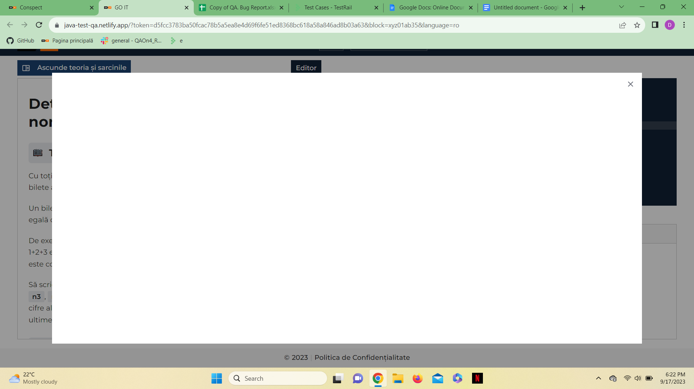

11.

| ID | BR-02 |  |  |  |  |
| --- | --- | --- | --- | --- | --- |
| **Reporter:** | Dumitrache Bogdan | **Assignee:** | <Tester> | **Status:** | New |
| **Type:** | Functional | **Severity:** | Minor | **Priority:** | Minor |
| **Browser:** | Google Chrome 101.0 | **OS:** | Windows | **OS version** | 11 |
| **Summary:** | Nefuntionalitate buton “X” din pagina “Politica de confidentialitate” | | | | |
| **Description:** |  | | | | |
|  | | | | |
| **Pre-conditions:** | | | | | |
| 1 | Acesati conform BR-01 | | | | |
| 2 |  | | | | |
| **Steps to reproduce:** | | | | | |
| 1 | Inchideti pagina folosind butonul “X” | | | | |
| 2 |  | | | | |
| 3 |  | | | | |
| 4 |  | | | | |
| **Actual result:** | | | | | |
| Pagina nu se inchide | | | | | |
|  | | | | | |
| **Expected result:** | | | | | |
| Pagina se inchide | | | | | |
|  | | | | | |
| **Attachments:** |  | | | | |
| **Additional info:** | | | | | |
|  | | | | | |
|  | | | | | |